**Information System Management Lab**

**BCOM 307**

**Assignment #1**

***Submitted by:***

**Name:** YASH JAIN

**Enrollment No:** 03914788818

**Semester:** 5th Sem

**Class:** B.Com(H)

**Section**: BCom 5A

**Date of Submission**: 05/09/2021

***Submitted to:***

**Praveen Kumar Singh**

**Assistant Professor, MAIMS**



**Department of Commerce**

**Maharaja Agrasen Institute of Management Studies**

**Affiliated to Guru Gobind Singh Indraprastha University, Delhi**

**Sector -22, Rohini, Delhi -110086, India; www.maims.ac.in**

Maharaja Agrasen Institute of Management Studies

Affiliated to GGS IP University; Recognized u/s 2(f) of UGC Recognized by Bar Council ofIndia; ISO 9001: 2015

Certified Institution Sector 22, Rohini, Delhi -110086, India; [www.maims.ac.in](http://www.maims.ac.in/)

Department of Commerce

Academic Year: 2020-21

Semester: Vth

# Assignment No.1

# Unit No: 1

**Course/ Subject Code:** BCOM 307 **Subject Title: Information System Management Lab**

# Issue Date: Last Date of Submission:

**Instructions for Students:**

# All Questions are Compulsory.

1. The student should attach proper cover page for each assignment clearly mentioning the Assignment No.
2. Each assignment should be prepared by the student individually with proper explaination and screenshots.
3. A4 size ruled sheets should be used for the assignment.
4. Assignment pages should be serially numbered at the bottom of page.

***During online education mode, upload scanned copy of the complete assignment including cover page latest by due date.***

|  |  |  |
| --- | --- | --- |
| **Question No.** | **Question** | **CO**  **No.** |
| 1 | Create a table called “Persons” that contains five columns:   1. PersonID INT 2. FirstName Char(20) 3. LastName Char(20) 4. Address Varchar(25) 5. City char(15) | **CO1** |
| 2 | Insert any 5 values in the table “Persons” |
| 3 | View All records of the table “Persons” |

**ASSIGNMENT 1 - BASIC TABLE COMMANDS**

**Task 1 : Create Table ‘Persons’ with the following specifications:**

|  |  |
| --- | --- |
| **Column Name** | **Data Type** |
| PersonID | Int |
| FirstName | Char(20) |
| LastName | Char(20) |
| Address | Varchar(25) |
| City | Char(15) |

The following task is completed using the ‘**create table’** command. The syntax of the command to create a table with ‘x’ number of columns is given as –

create table tablename (column1 datatype, column2 datatype, . . . . . . . columnx datatype);

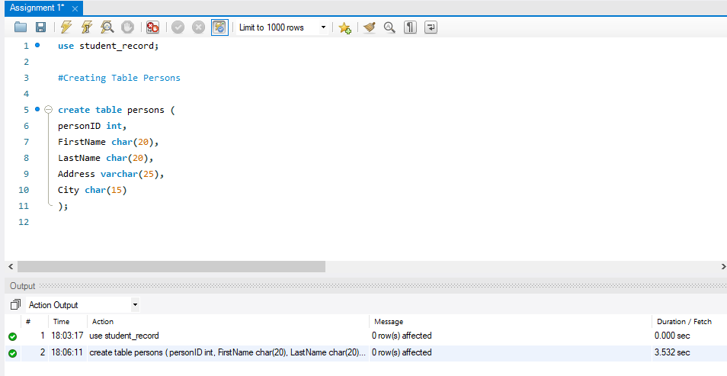

**Task 2: Insert any 5 values in the table ‘persons’.**

The given task can be completed using the **‘insert into’** command. The syntax for this command to enter a value in the table is given as –

insert into tablename(column1 datatype, column2 datatype, . . . . . . . columnx datatype) values (value for column1, value for column2, . . . . . . . value for columnx)

Note: The values entered have to be in single commas (‘’) for values of **char** and **varchar** entries, while it is not required in the case of **int** value entries.

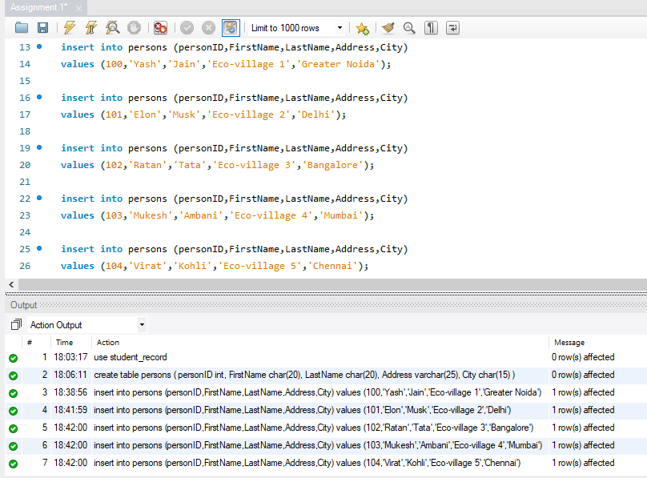

**Task 3: View all the records in the table ‘persons’.**

This task can be completed by using the command **‘select’**. This command selects the columns that need to be displayed/viewed. To view all the records, we use the asterisk (*). The syntax for this command is:

select column1,column2,. . from table; (for specific columns)

select * from table; (for all the records)

